--

|  |
| --- |
| **What are we learning?** |
| **Reading**  Comprehension Skill: Nonfiction Text, Summarize, Roots and Affixes, Compare/Contrast  Word Study Skill: Open Syllables  Example Words:  bacon, tiger, table, program, recent, silent  **Language/Writing:**  This week students will finish their study of nouns; including plurals, iregular plurals, and possessive nouns.  **Math:**  Study guide for Topic 3, Multiplication of Single Digit by 4 Digit Numbers, is due on Thursday, October 3 for a test on Friday. Thank you for using flashcards and Reflex to review math facts.  **Science:**  We will continue focusing on sound as a form of energy. Students should use their study guide to review the three forms of energy, heat, light and sound. The test is planned for October 4th.  **AL History:**  Students will focus on the conflicts between early Colonists and the Native American tribes. They should understand the causes and effects of the Creek Civil War. |
|  |
|  |
|  |

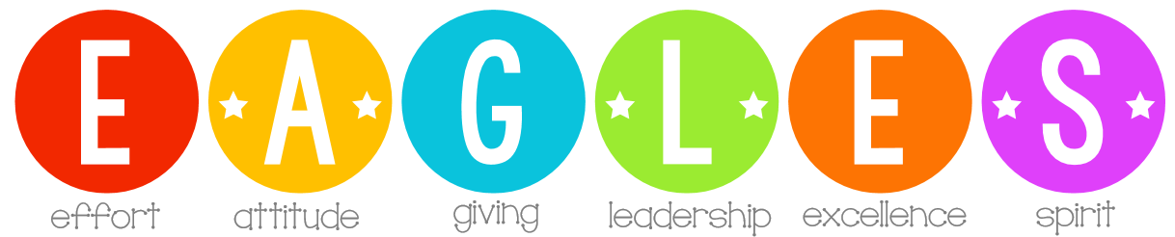

**Dates to Remember**

* Thurs., October 3rd:

Fill the Mill Celebration from 5:15-6:15 p.m.

* Thurs., October 10th:

End of the 1st Quarter Term

* Tues., October 15th:

Horseshoe Bend Field Trip

* Fri., October18th:

No School

* Mon., October 21st:

No School – Parent Conference Day

Fill the Mill is Oct. 3rd 5:15-6:15 in the field next to WMR.

### Week of:

### Sept. 30-Oct. 4

New From Mrs. Neighbors

_______________________________________________________

_______________________________________________________

_______________________________________________________

_______________________________________________________



MCj03979950000[1]

We are excited to take our first field trip of the school year!

We will travel on school buses, leaving around 8:30 and returning by 1:30, before the end of the regular school day. Please look for a permsion slip to sign and return. Payments can be made by sending in cash, check, or through MySchoolBucks online.

